

|  |
| --- |
| **Title: Python Application Development** |

**AIM :** To develop a python application for a real world problem

**______________________________________________________________________**

**Expected OUTCOME of Experiment:**

**CO:**

**________________________________________________________________**

**Books/ Journals/ Websites referred:**

1.

**Github Link of Project files :** [**https://github.com/NidhiBhanushali3701/KeyBase**](https://github.com/NidhiBhanushali3701/KeyBase)

**Problem definition:**

Creating strong passwords is a necessary procedure in order to stay safe online. Unfortunately, complex passwords are difficult to remember; besides, you need to create a separate password for each account. For example, if you have 10 login passwords for different Internet accounts, memorizing becomes very difficult, especially if you are changing them every 3 months. Fortunately, there is a solution for this problem as for many others.

Password manager helps you to organize your passwords according to each Internet service used. You can set complex passwords for each account and retrieve them easily when needed. This system is so crucial these days because there are so many different applications in the market and remembering username and passwords for each of them is a difficult task for one person.

In this project we aim to solve this problem by creating a python application which will store a particular user’s passwords for different applications along with the username and email he has used for that application. The user can access all his passwords using one master password and username.

**Scope:**

Scope of the project is implemented as follows

* User Registration & Login functionality using GUI
* Adding new passwords for each user
* Updating Existing Details in the database.
* Deleting existing passwords from the database

**Component diagram:**

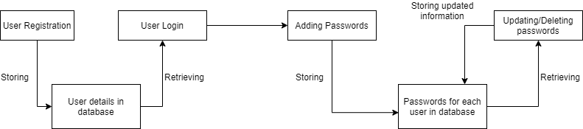

**API or package used:**

Packages and modules used in the project

1. Python tkinter: for creating User-Interface of the application
2. Python sqlite3: for Database

**Difficulties faced and measures taken to resolve:** The major difficulty faced by us was to create a table and enable selecting of rows inside it to allow users to edit the values that they have previously set. In order to achieve this, we used a TreeView which is available in tkinter.

**Team work (Contribution of each member)**

Nidhi - Front & Back End (Main Page, Create new, Update)

Kashish - Front & Back End (Login, Register, Delete)